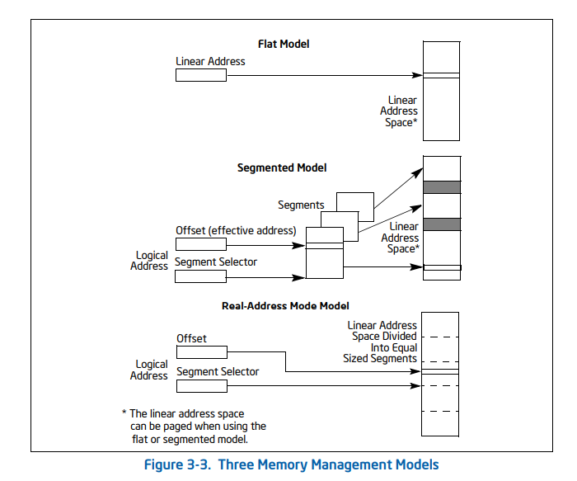

Memory model determines how the program is placed in RAM and how RAM is allocated for it.